Name: Asif Hasan

ID: 19-41153-2

Vending Machine

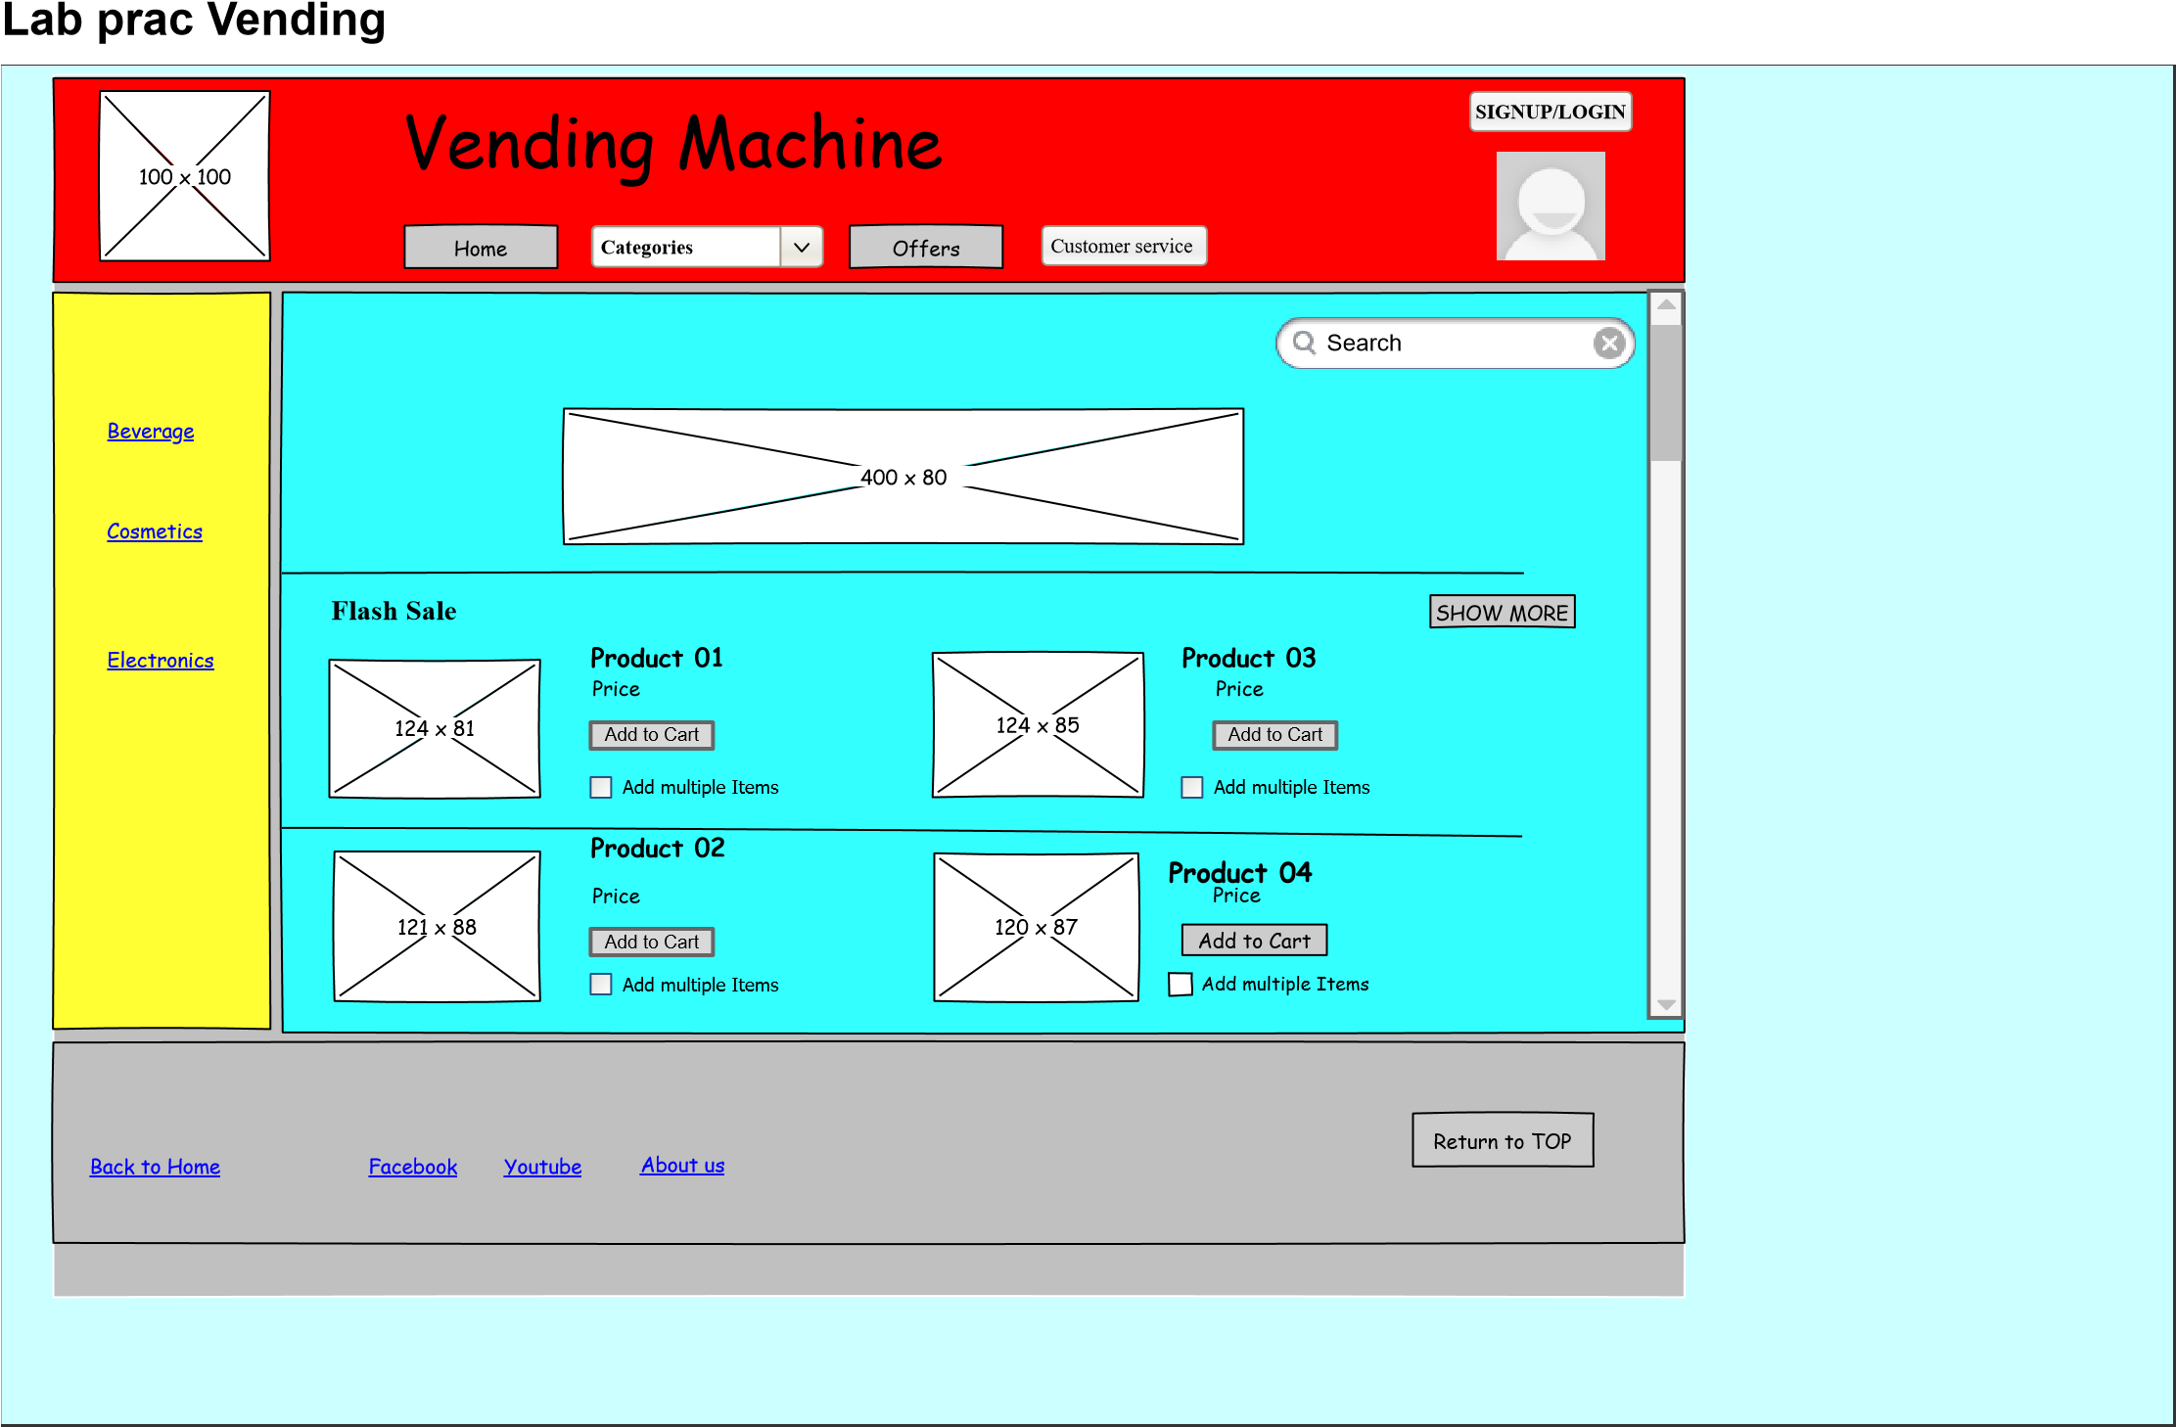

Fig: Home page

2nd

|  |  |  |  |  |  |  |  |  |  |  |  |  |  |  |  |
| --- | --- | --- | --- | --- | --- | --- | --- | --- | --- | --- | --- | --- | --- | --- | --- |
| 100  x  100  Vending Machine  Home  Offers  Customer service  Categories  SIGNUP/LOGIN   |  |  |  |  |  |  | | --- | --- | --- | --- | --- | --- | | BEVERAGE  FOOD  ELECTRONICS | Home > Categories > cosmetics  Flash Sales  100  x  100  Show More | 457  x  141 | | Search |  | | 260  x  182  Product 01 |  | 260  x  182  Product 02 | 260  x  182  Product 03 | | Back to Home | Facebook Youtube About us |  | | Return to TOP | |

Fig: Cosmetics catagories

3rd

|  |  |  |  |  |  |  |  |
| --- | --- | --- | --- | --- | --- | --- | --- |
|  | 100  x  100 | Vending Machine  Home  Categories  Offers  Customer service | | SIGNUP/LOGIN | |  |  |
| BEVERAGE  FOOD  ELECTRONICS | Home > Categories > Beverage  Flash Sales  100  x  100  Show More  457  x  141 | | Search | |  |
| 260  x  182  Product 01 | Product 02  260  x  182 |  | Product 03  260  x  182 |
| Back to Home | Facebook Youtube About us | | Return to Top | | |
|  | | | | | |